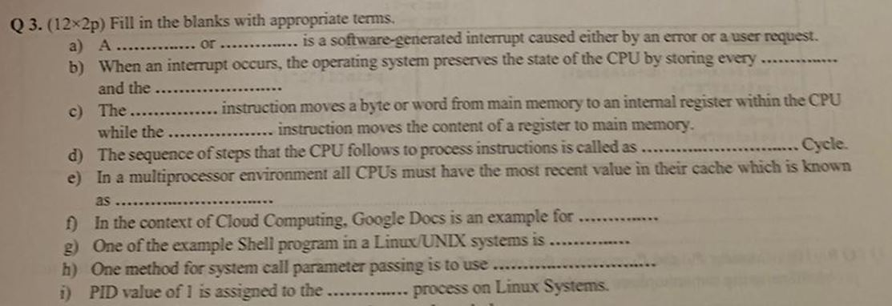

- A trap or exception is a software-generated interrupt caused either by an error or user request.
- When an interrupt occurs, the operating system preserves the state of the CPU by storing every register and the program counter.
- The Load instruction moves a byte or word from main memory to an internal register within the CPU, while the Store instruction moves the content of a register to main memory.
- The sequence of steps that the CPU follows to process instructions is called the Instruction Cycle or Machine Cycle.
- In a multiprocessor environment, ensuring that all CPUs have the most recent value in their cache is known as maintaining cache coherence.
- In the context of cloud computing, Google Docs is an example of Software as a Service (SaaS).
- One of the examples of a shell program in a Linux/UNIX system is Bash (Bourne Again SHell).
- One method for system call parameter passing is to use registers.
- On a Linux system, the process with PID (Process ID) value of 1 is assigned to the init process.

